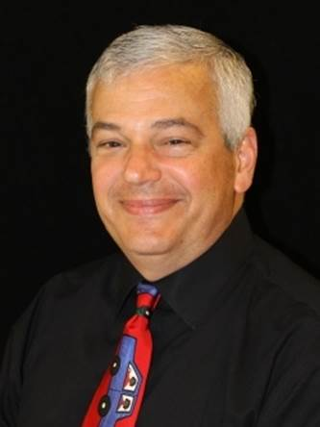

**Mark Altmar:**

I’ve been on the board for two and a half years, and this is my eleventh year of being associated with RTS.

I’ve been a resident of Spokane for the last twelve years.

I like any program or non-profit that believes in giving people a hand up not a hand out.

In my off time, I enjoy gardening, riding my bicycle, and fishing.

Go Seahawks!

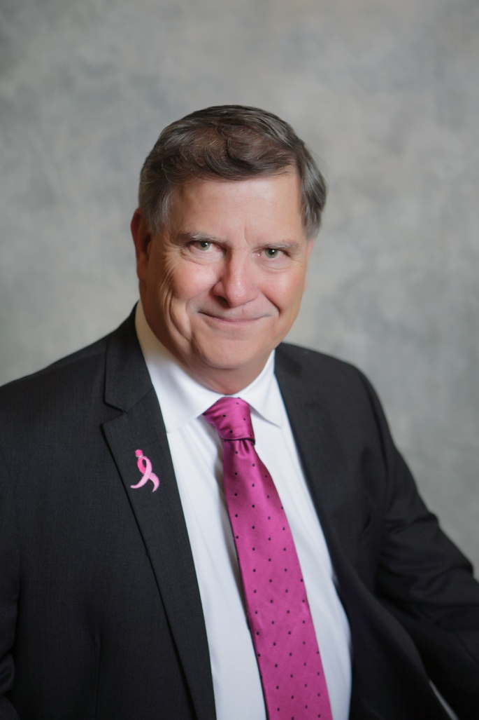

**Todd Harnetiaux**

President Modern Construction & Consulting Services

Board Member – 3 Years

Initially got involved with the local chapter after spending 2 years working with Gonzaga & Rebuilding Together on Katrina Homes in New Orleans.

I am a Board Member on other local Non-Profit Organizations and a graduate of Leadership Spokane.

Jandyl

Board member for 2 years

I have spent most of my working career in some sort of food service from Restaurants to Non-Profits, but always feeding people. I am an avid gardener, love to cook and a triathlete. I love my girls, but they grew up too fast and I have three wonderful grandchildren.

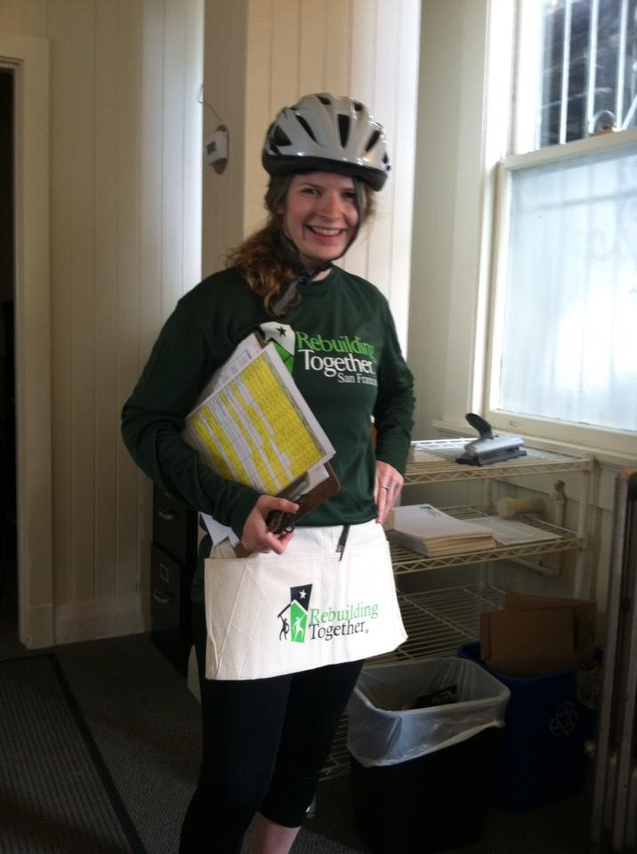

Stephanie Lilla

I am a Community Organizer for Coordinated Care and have been on the board for just over a year. I have a huge passion for affordable housing and love what Rebuilding Together Spokane provides local residents in need. I am Gonzaga alumna and first became involved with Rebuilding Together through serving an AmeriCorps term with Rebuilding Together San Francisco as their Volunteer Coordinator

I enjoy doing everything and anything outdoors; hiking, cycling, skiing, snowshoeing as well as playing recreational sports. I am an avid Zags fan and enjoying spending time with family and friends. Born in raised in Portland, OR I have heart for the Northwest!

“Safety First!”

Christie Vranich

Kenalynn Merkel

Corey Plager